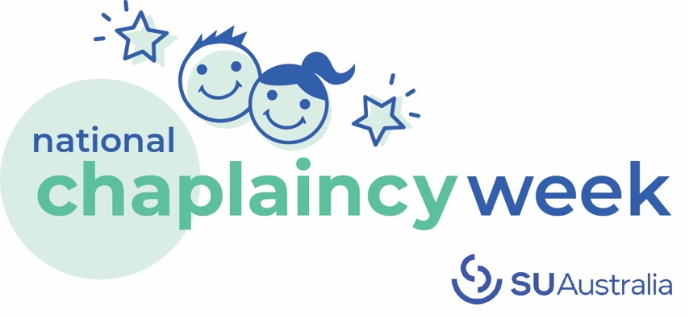
You’re invited to a breakfast for ‘Chaplaincy Week’

[Date]
Dear [Salutation],

I’d like to invite you to help [name of school] celebrate Chaplaincy Week on [insert date].

Communities across Australia will be celebrating National Chaplaincy Week from Sunday 19 May to Sunday 26 May. And what better way to celebrate than to raise awareness for this great cause!

The aim of Chaplaincy Week is to celebrate and support the work of school chaplains.

As the largest registered provider of school chaplains across the country, SU Australia employs over 740 school chaplains in more than 1029 schools nationwide. Many school chaplains rely on vital community support and funding, and Chaplaincy Week can be a great opportunity to spread the word about what this service is all about.

Many chaplains run breakfast clubs every week to feed students who have missed out on breakfast before arriving at school. It’s quite common for chaplains to host a special “Chaplaincy Breakfast” over this week. If you’re in the position to donate food items, volunteer your time, or give a financial gift to help our local chaplaincy service host a breakfast event, I’d love to hear from you. You can contact me on [mobile number].

Alternatively, Chaplaincy Week is a great way to showcase your connections with local community initiatives!

With many families doing it tough in 2024, Chaplaincy Week is an opportunity to give back to the young people and families in your local community by supporting this work financially, practically or in a volunteer capacity. If you are a business owner, you might wish to donate a percentage of your sales back to your local chaplaincy service for this week, as a number of other businesses have done over the years.

If you are interested in supporting your local community through school chaplaincy, I look forward to hearing from you. For more information on Chaplaincy Week and chaplaincy in general, visit su.org.au/chaplaincyweek.

Yours sincerely,

[Name and Title]

